Project Report: Online Retail Data Analysis Using SQL

1. Introduction
Objective:
The primary goal of this project is to analyze an online retail dataset using SQL to extract valuable insights into customer behavior, product affinity, purchase patterns, and customer segmentation. By leveraging SQL queries, we aim to identify key customer segments, understand purchasing behavior, and determine opportunities for enhancing marketing strategies and improving customer retention.
Dataset Overview:
The dataset consists of transactional data from an online retail store, containing details such as invoice numbers, product codes, descriptions, quantities, invoice dates, unit prices, customer IDs, and countries. This data was analyzed using SQL queries executed in MySQL Workbench.

2. Tools and Technologies Used
- SQL Tool: MySQL Workbench
- Database Management System: MySQL
- Programming Language: SQL
- Data Source: Online Retail dataset

3. SQL Queries Executed and Analysis
Beginner Queries:
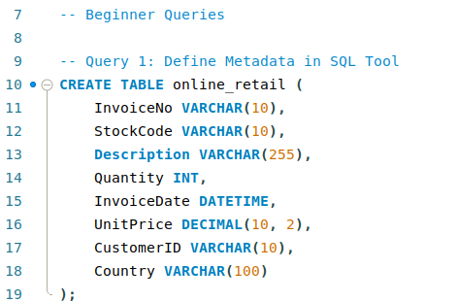
- Define Metadata in SQL Tool
Created a table structure (online_retail) to store data using SQL.

- Distribution of Order Values Across All Customers
Calculated the total order value for each customer to determine top spenders.

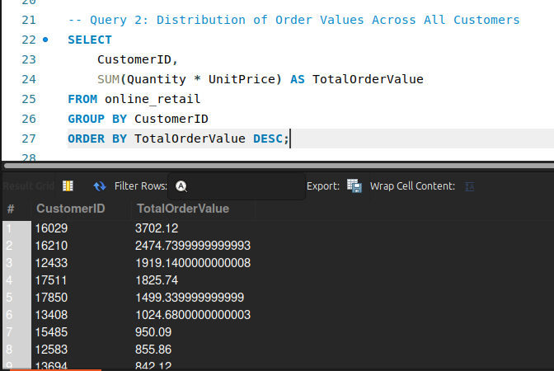

- Unique Products Purchased by Each Customer
Identified the number of unique products purchased by each customer.
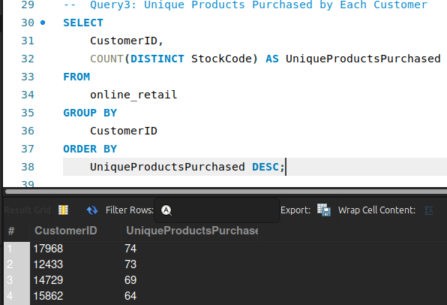

- Most Commonly Purchased Products Together
Determined which products are most frequently bought together.
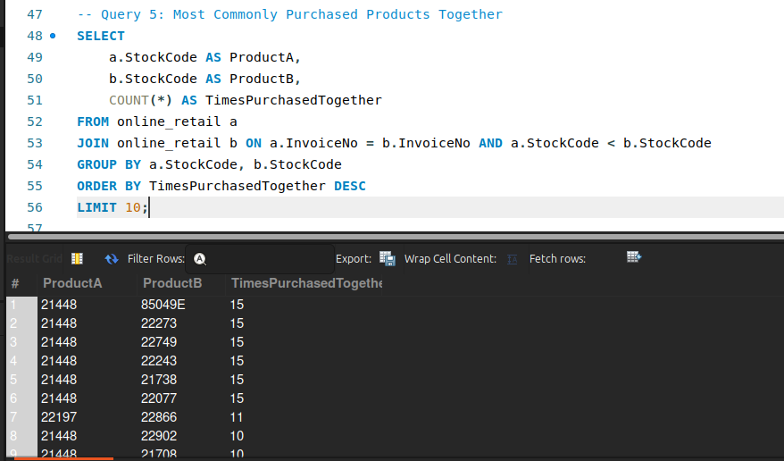
- Advanced Queries:
- Customer Segmentation by Purchase Frequency
Segmented customers based on their purchase frequency into High, Medium, and Low categories.

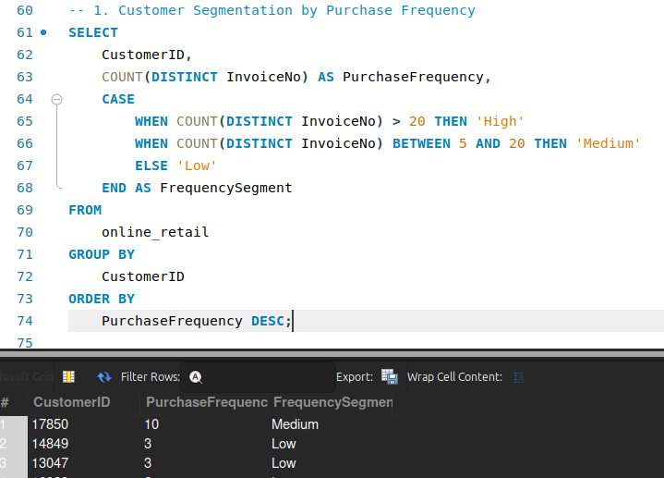

- Average Order Value by Country
Computed the average order value for each country to identify the most valuable markets.
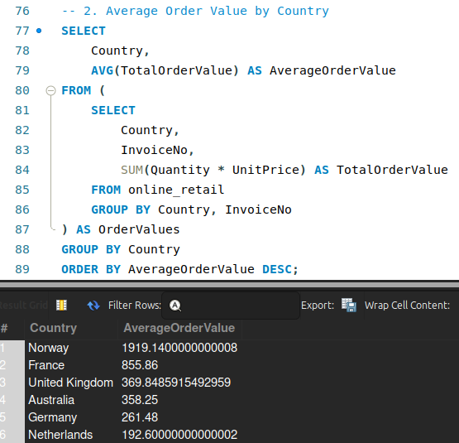

- Time-Based Analysis
Analyzed sales patterns by month and quarter to identify seasonal trends.
- Monthly Sales Pattern:
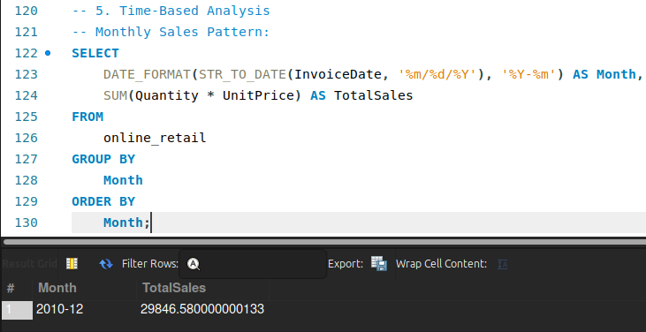

- Quarterly Sales Pattern:
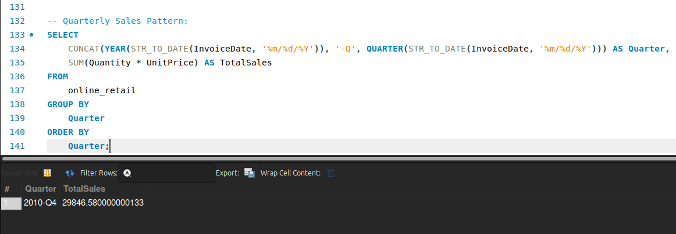

4. Key Findings and Insights
- Top Spenders: Identified the highest-value customers based on total spending, allowing targeted promotions and loyalty programs.
- Customer Segmentation: Segmented customers into high, medium, and low-frequency groups to tailor marketing efforts accordingly.
- Product Affinity: Highlighted commonly co-purchased products, providing insights for cross-selling and bundling opportunities.
- Customer Churn: Identified customers at risk of churning, enabling proactive retention strategies.
- Seasonal Trends: Monthly and quarterly sales patterns provided data for inventory management and sales forecasting.

5. Conclusion and Future Work
This analysis of the online retail dataset using SQL has provided valuable insights into customer behavior, product preferences, and sales patterns. The findings can help guide strategic decisions, optimize marketing efforts, and enhance customer retention strategies.
Future Enhancements:
- Utilize Business Intelligence (BI) tools for advanced data visualization.
- Develop predictive models using machine learning to forecast customer behavior.
- Extend customer segmentation using additional demographic and behavioral data.

6. GitHub Profile
- GitHub Profile: https://github.com/ayankarim101

